Innovation Lab Executive Summary

AECSD elementary Library Media Specialists were tasked with creating and facilitating Innovation Lab spaces in each building. Purchases were funded through the AEF grant and included: Makey Makeys, Ozobots, and other consumables which lend themselves to the design process (i.e., Legos, straws, etc.) Since September, students have been learning about the Engineering Design Process, and have focused on collaboration, developing an innovative mindset, and FAIL as First Attempt In Learning (or opportunity to improve). Given the literary expertise of the library media specialists, the Innovation Lab has included “Novel Engineering” lessons which is an integrated approach to teaching engineering and literacy. In short, students use a given picture book, like The Snowy Day by Ezra Jack Keats, as the basis for engineering design challenges that help them identify problems, design realistic solutions, and engage in the Engineering Design Process while reinforcing their literacy skills.

Library Media Specialists continue to attend professional development opportunities offered by Cayuga-Onondaga BOCES, and have enlisted the assistance of Renee Lawrence, CO BOCES Technology Integration Specialist. This partnership provides the Library Media Specialists with insight and personalized learning on how best to incorporate Innovation Lab lessons into the current program. Teachers are reporting a boost in student engagement and an increased interest in developing the ability to make improvements and persevere in problem solving.

Individual Building Activity Updates

Casey Park Elementary
- “Tackling Plastic!”: National Geographic Challenge-5th and 6th graders
  - Students work in teams to problem-solve plastics in our waterways.
  - Project ties in with guest author visit. Select students will present projects at evening author event on March 28.
- Typing Club: Keyboarding skills for grades 3-6
- Digital Citizenship Lessons for K-3
- Arts Collaboration: 4th grade mask project in conjunction with Art
  - Students are creating Google slideshow presentations
- Coding with Google’s “Santa Tracker”

Seward Elementary
- “Tackling Plastic!”: National Geographic Challenge-5th and 6th graders
  - Students work in teams to problem-solve plastics in our waterways.
  - Project ties in with guest author visit. Select students will present projects at evening author event on March 28.
- Building Water Filters
  - 4th graders tackle constructing water filters in connection with the book I Am Farmer written by our visiting authors Miranda and Baptiste Paul.
- Ozobots
  - Students in grades 2-5 experience drawing code for robots to follow
- Typing Club: Keyboarding skills for grades 3-6

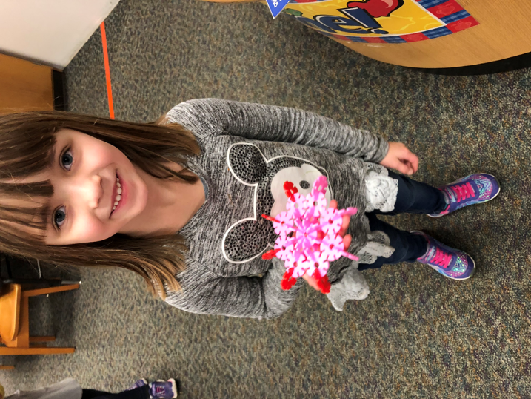
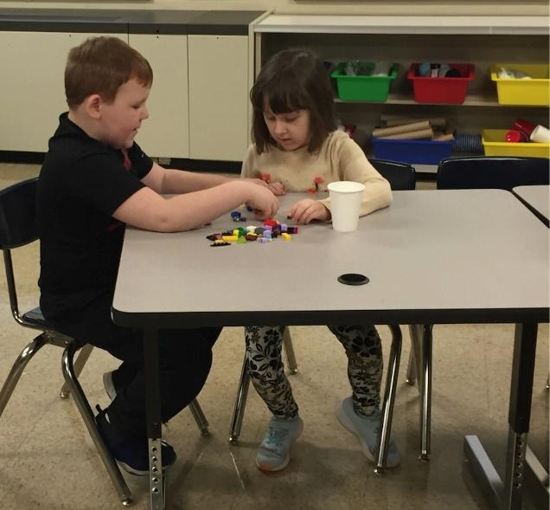

Genesee Elementary
- “Tackling Plastic!”: National Geographic Challenge-5th and 6th graders
  - Students work in teams to problem-solve plastics in our waterways.
  - Project ties in with guest author visit. Select students will present projects at evening author event on March 28.
- Typing Club: Keyboarding skills for grades 3-6
- Makey Makey Introduction with 3rd grade students
- Google Classroom with grades 3- 6
- Google Applied Digital Skills Curriculum Unit with 6th grade students
- I-Lab orientations/Engineering Design Process with grades 3 and 4
- Digital Citizenship Lessons for K-3
- Database research on Cameroon
  - Recorded Flip Grids with facts in grades 4-6
- Keva Plank Challenge in grades 2-3
- Novel Engineering Projects connecting picture books and building structures
  - Keva Planks, Brain Flakes, Dominoes, Legos, wooden sticks
- Google “Animate a Name” Coding activity with 6th grade
- Hour of Code activities with Dash & Dot robots and Blockly K-1

Herman Ave Elementary
- “Tackling Plastic!”: National Geographic Challenge-5th and 6th graders
  - Students work in teams to problem-solve plastics in our waterways.
  - Project ties in with guest author visit. Select students will present projects at evening author event on March 28.
- Typing Club: Keyboarding skills for grades 3-6
- Digital Citizenship Lessons for K-6
  - Curriculum created in collaboration with classroom teachers July 2018
- Arts Collaboration: Robot Building
  - Online computer drawing project utilizing the book Trainbots by Miranda Paul (visiting author)
- Google Classroom with 4th grade
- Discovery Education Electronic Board Builder with 5th grade
- Introduction to the Engineering Design Process grades K-6
- Video conferences with various classes

Owasco Elementary
- “Tackling Plastic!”: National Geographic Challenge-5th and 6th graders
  - Students work in teams to problem-solve plastics in our waterways.
  - Project ties in with guest author visit. Select students will present projects at evening author event on March 28.
- Novel Engineering Projects connecting picture books:
  - Students in 1st and 4th grade work to solve problems using engineering design process by using picture books and their characters as clients
- Coding/Robotics
  - Kindergarten and 2nd grade students learn basic computational thinking using BeeBots
- Digital Citizenship Lessons for K-6
  - Curriculum created in collaboration with classroom teachers July 2018
- Typing Club for Grades 3-6

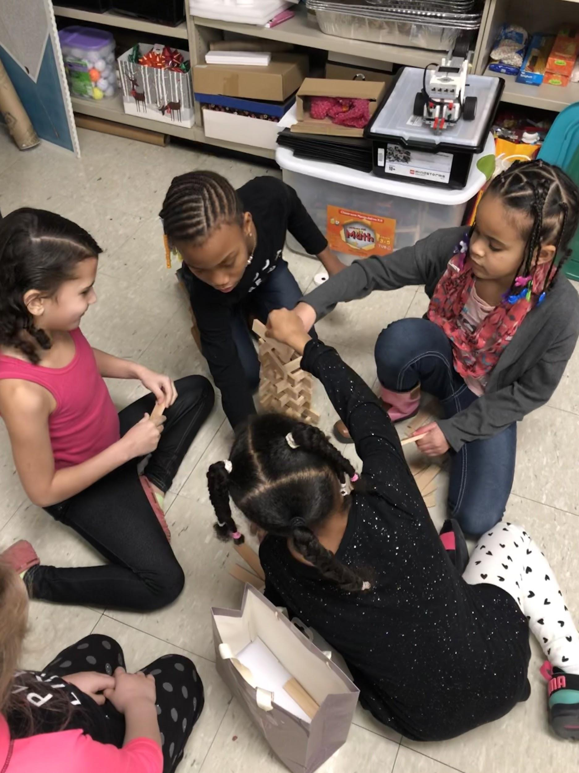
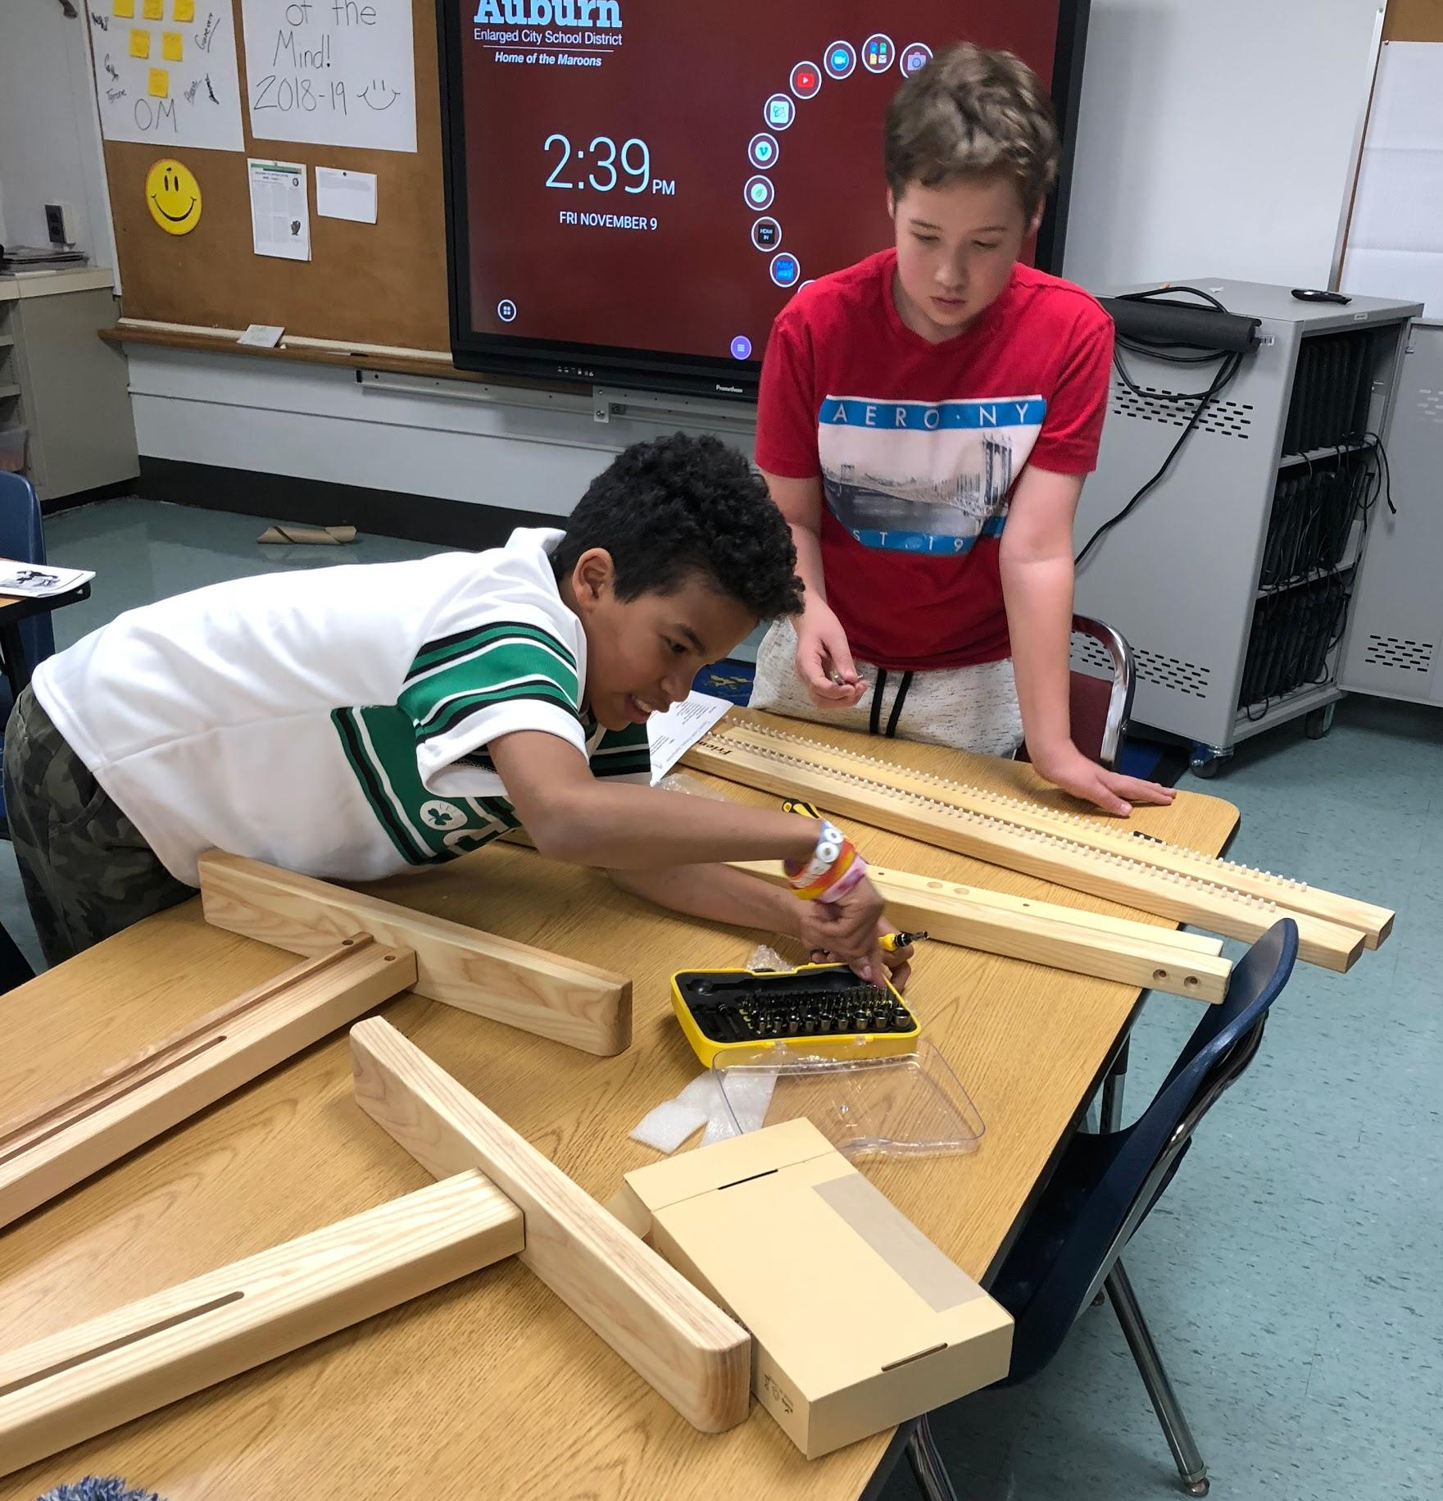

Innovation Labs in Action!
